Trend Analysis and Prediction For Long Term Rental:

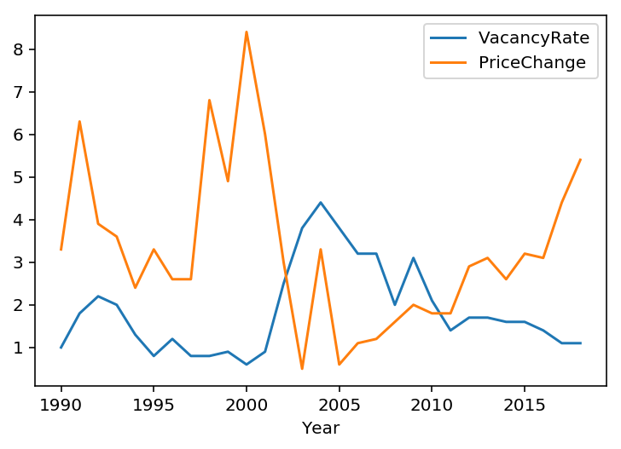

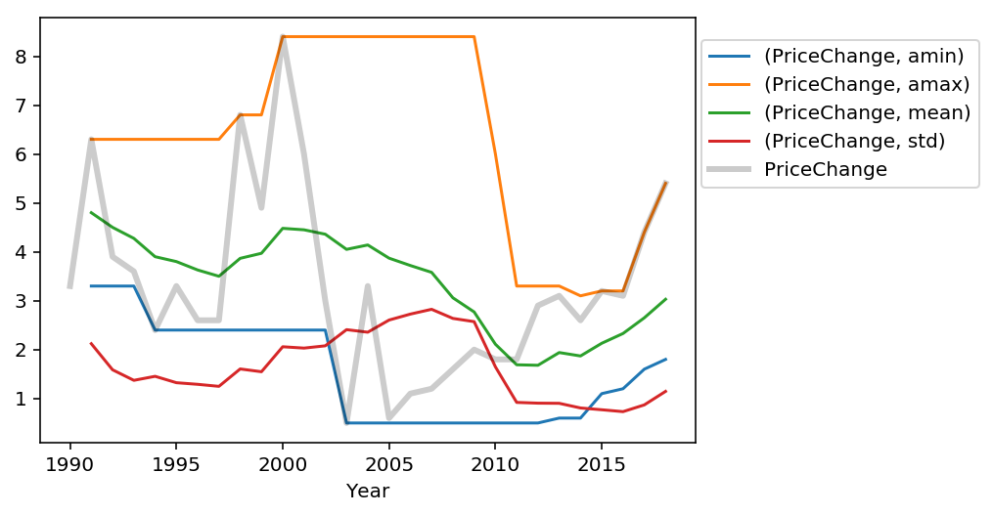

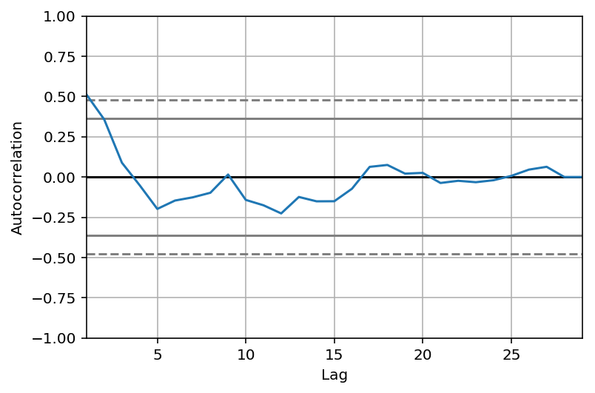

When we plot the autocorrelation of the 'PriceChange' series: on the x-axis, you have the lag and, on the y-axis, you have how correlated the time series is with itself at that lag. So, this means that if the original time series repeats itself every two years, you would expect to see a spike in the autocorrelation function at 2 years. Looking at the plot we see a spike in the autocorrelation function at 9 years: the time series is correlated with itself shifted by 9 years. So, we have identified the seasonality of 9 years repetition!

**Time series forecasting with ARIMA**

We are going to apply one of the most commonly used method for time-series forecasting, known as ARIMA, which stands for Autoregressive Integrated Moving Average.

ARIMA models are denoted with the notation ARIMA(p, d, q). We should always run model diagnostics to investigate any unusual behavior. It is not perfect, however, our model diagnostics suggests that the model residuals are near normally distributed.

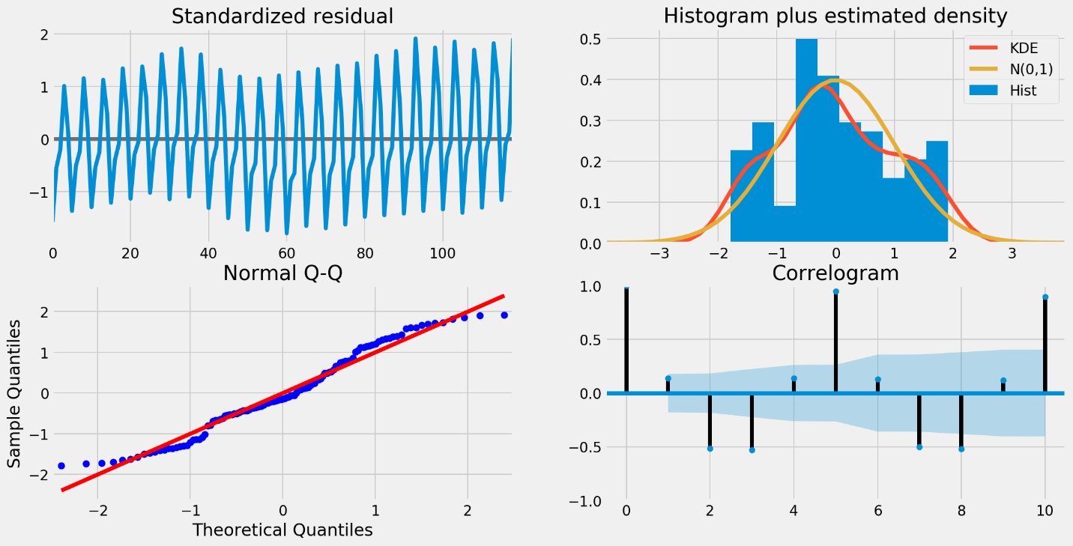

To help us understand the accuracy of our forecasts, we compare predicted sales to real sales of the time series, and we set forecasts to start at 2017–02–01 to the end of the data.

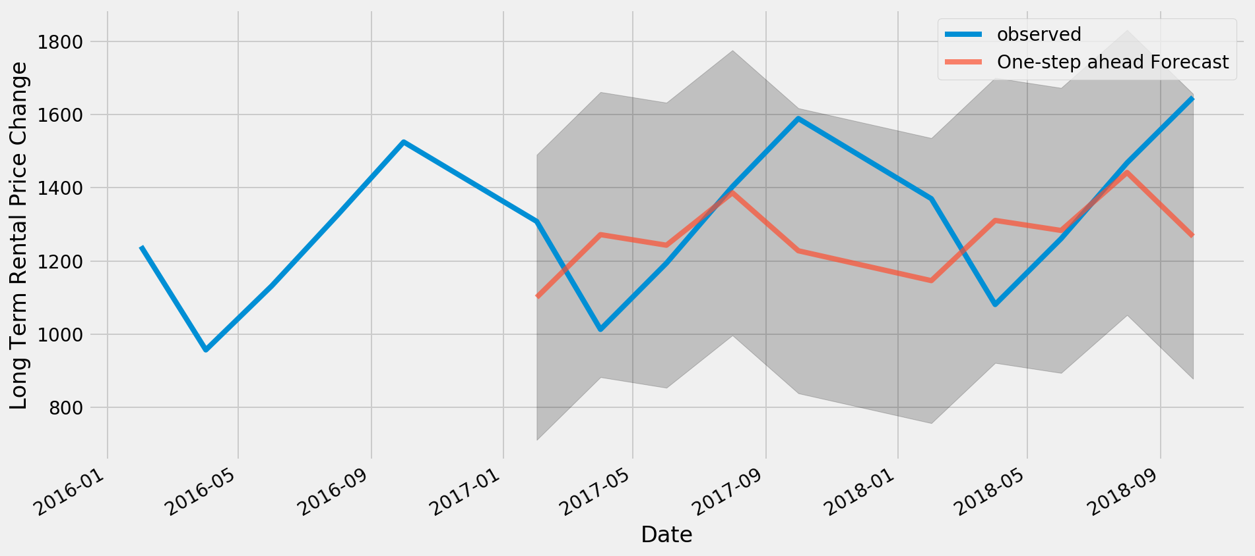

The Mean Squared Error of our forecasts is 1.16. The line plot is showing the observed values compared to the rolling forecast predictions. Overall, our forecasts align with the true values very well, showing an upward trend starts from the beginning of the year and captured the seasonality toward the end of the year.

####For Airnb part

##Housing Investment:

Factors: Accomodation Cost, Vacancy Rate, New Migration, Population how influencing new housing construction investment and overall housing market price: